**Array - A DVD box?**

Suppose you had a bunch of DVDs at home that you wanted to arrange neatly. What would be the ideal choice for storing such a thing? You could find a cardboard box (or some other box) big enough to arrange all of the DVDs neatly, right? It's as simple as that. However, you might want to add a new DVD to the box, or you might want to get rid of the old ones that you've watched a million times over in the past. An important consideration for this box would be that you would only place DVDs in it and nothing else; you wouldn't place your clothes in it, for example. The box would contain multiple items, but all of them would be of the same type. In this case, that type is DVD. Items of the same type share properties. For DVDs, those properties include:

* All the DVDs would be inside a plastic cover.
* The cover would have the name of the movie, the cast, and all sorts of other details.
* All the covers would be of exactly the same size and would contain just one, and only one, DVD.

You might not actually name the DVD box, but when you want your sister to fetch a DVD, you'd tell her that the DVD is inside your "DVD box", and she would instantly know where to find the box. This is a very simple yet realistic scenario that is easy to understand and relate to. So, now let us move over to the world of computers and port this example to programming.

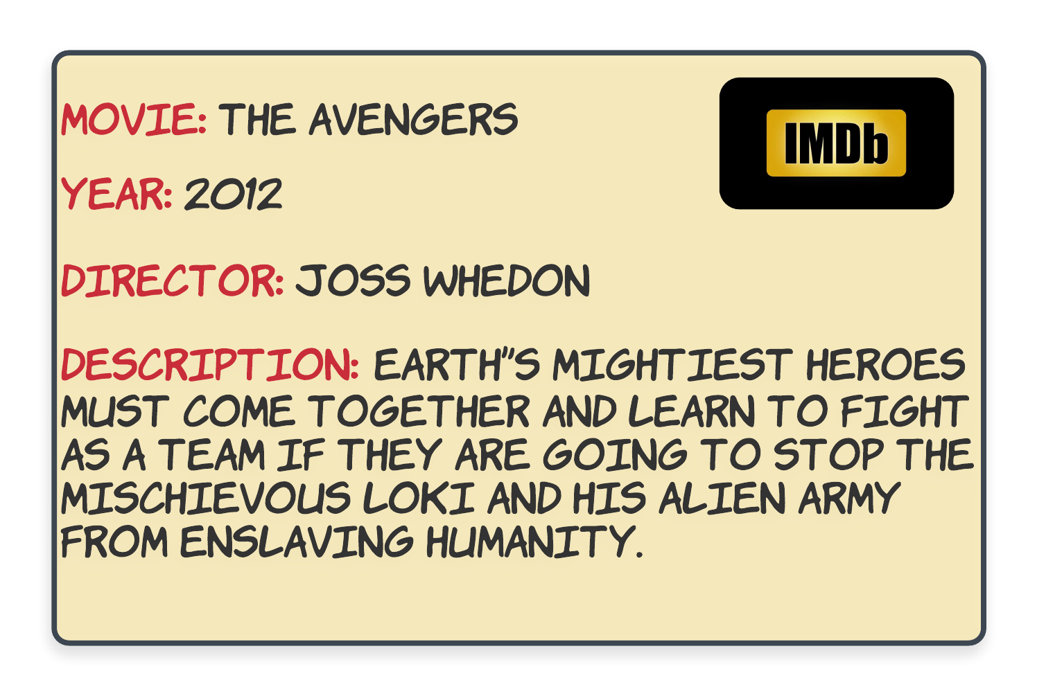

Suppose you were told that you needed to build some software to keep track of all the DVDs in an inventory. This is the exact same scenario that we just described above, but on a much larger scale. So let's imagine the DVD box as a virtual DVD library. For each DVD, you would have certain properties that would be specific attributes of the movies themselves.

In addition to the properties of a DVD, you're also told the maximum number of DVDs that can be stored in the inventory. Obviously, you wouldn't want to store ancient movies from the 1900s unless they were popular ones, right? Say you were told that the requirement is to maintain a maximum inventory of just 100 DVDs. This is an important piece of information because, without this, you wouldn't be able to find the *perfectly sized* box to fit all the DVDs easily. How could we find a box of a particular size that would be able to fit a maximum of 100 DVDs? Well, lucky for us, we don't need to physically find a cardboard box or anything—there's a programming construct for this purpose. That programming construct is known as an Array.